*Plenary Worksheet*

*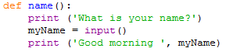*

What is the algorithm?

1. You write name().
2. It’ll ask what’s your name.
3. You will reply back by saying your name.
4. It’ll respond by saying ‘Good Morning [your name]